SCREEN SHOTS

To run project double click on ‘run.bat’ file to get below screen

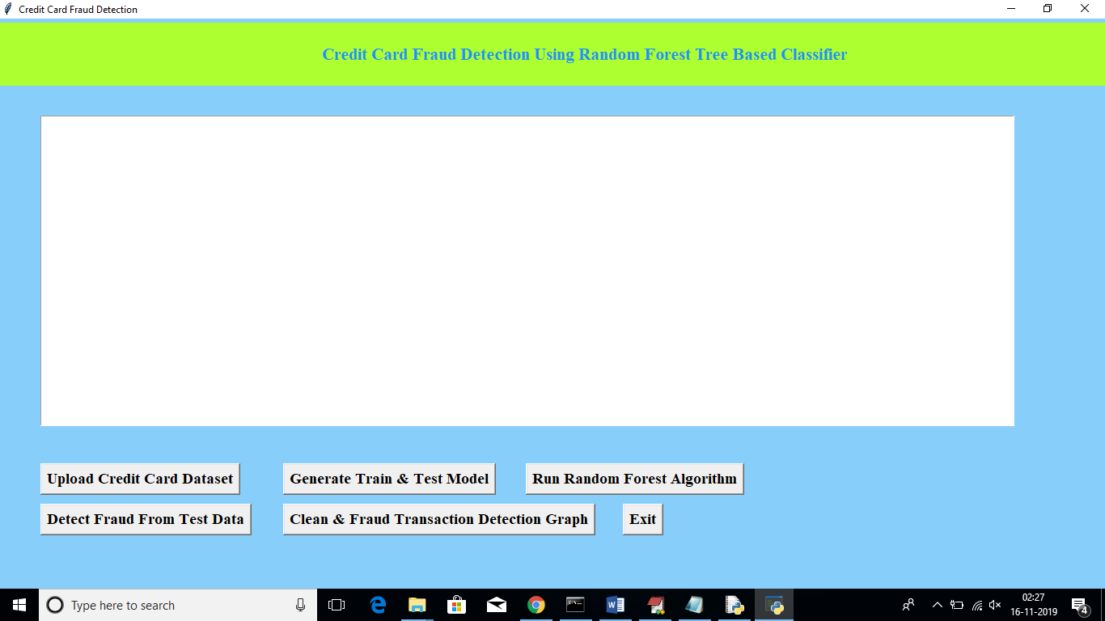

In above screen click on ‘Upload Credit Card Dataset’ button to upload dataset

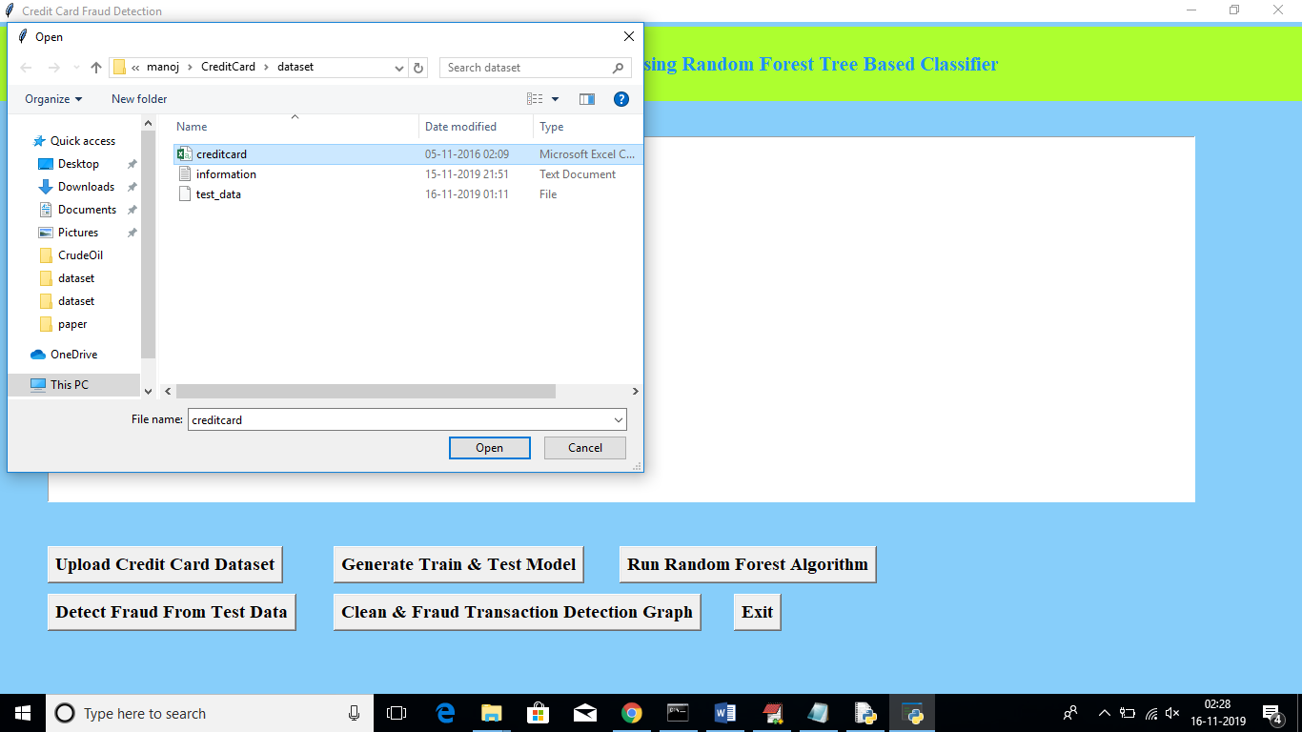

After uploading dataset will get below screen

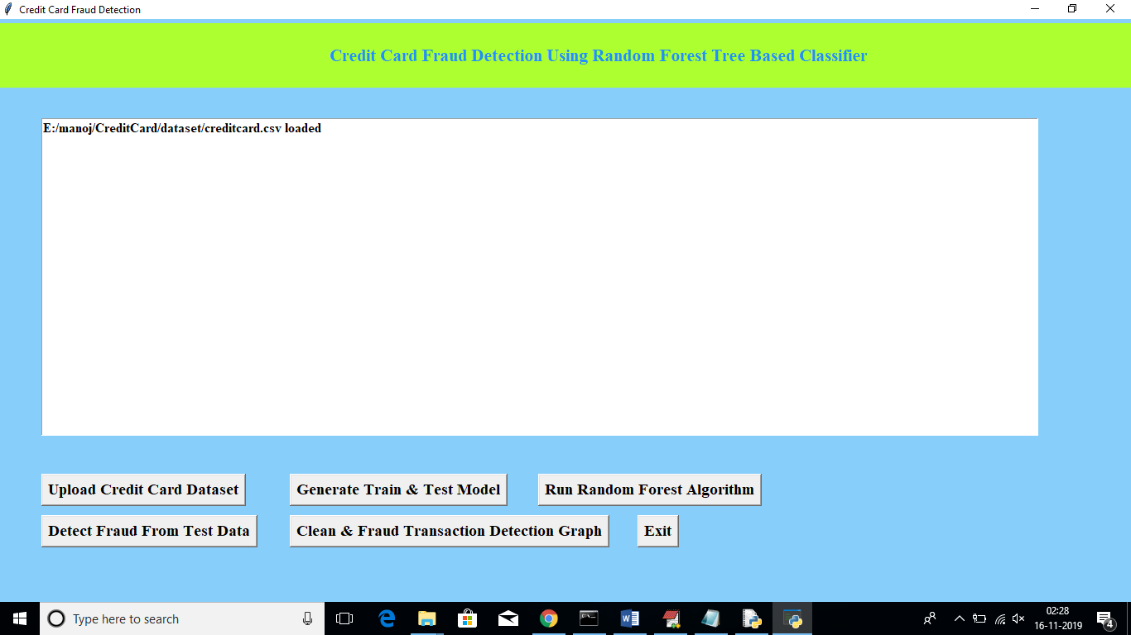

Now click on ‘Generate Train & Test Model’ to generate training model for Random Forest Classifier

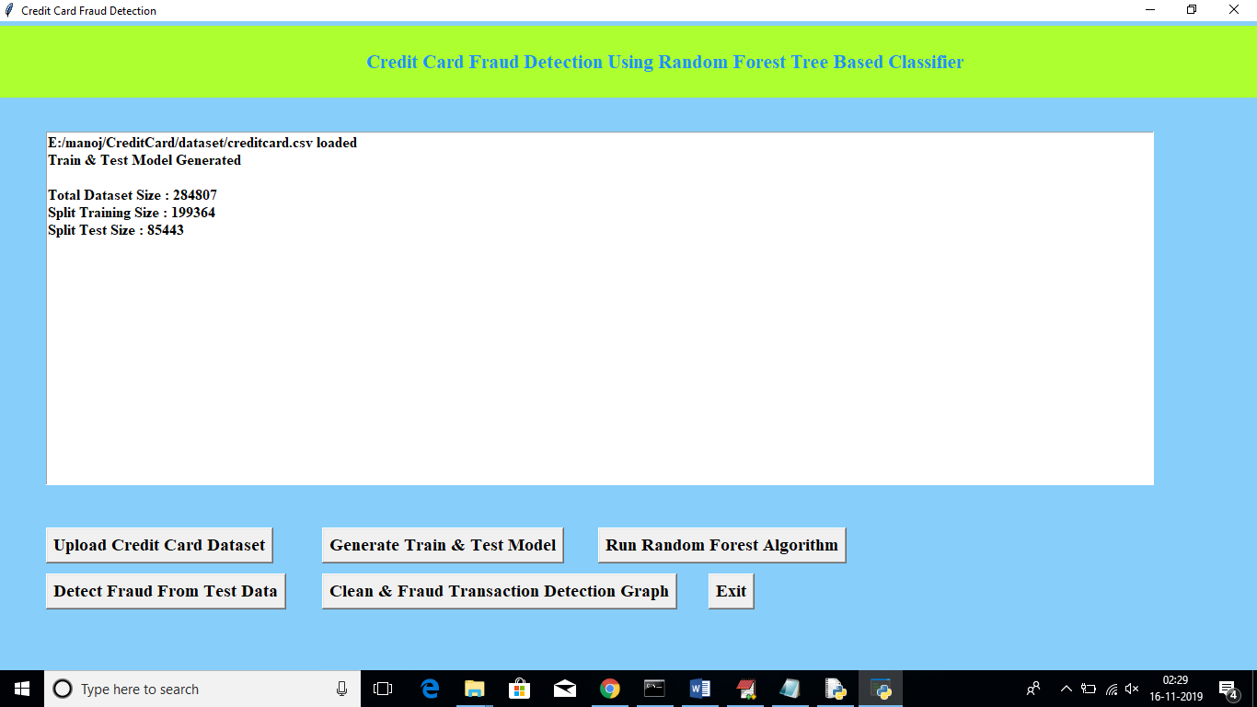

In above screen after generating model we can see total records available in dataset and then application using how many records for training and how many for testing. Now click on “Run Random Forest Algorithm’ button to generate Random Forest model on train and test data

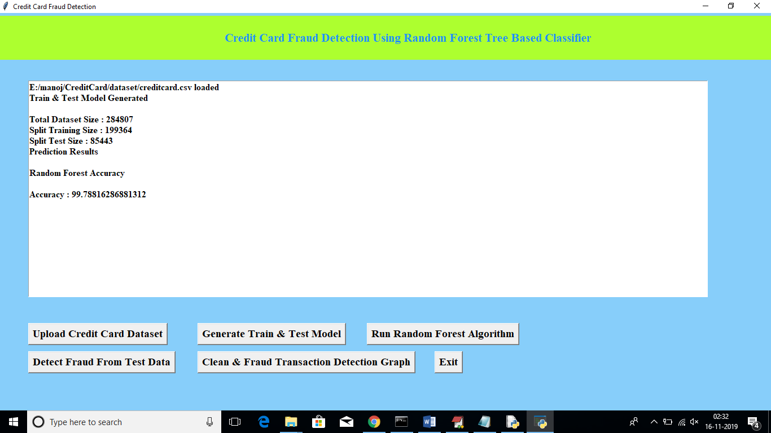

In above screen we can see Random Forest generate 99.78% percent accuracy while building model on train and test data. Now click on ‘Detect Fraud From Test Data’ button to upload test data and to predict whether test data contains normal or fraud transaction

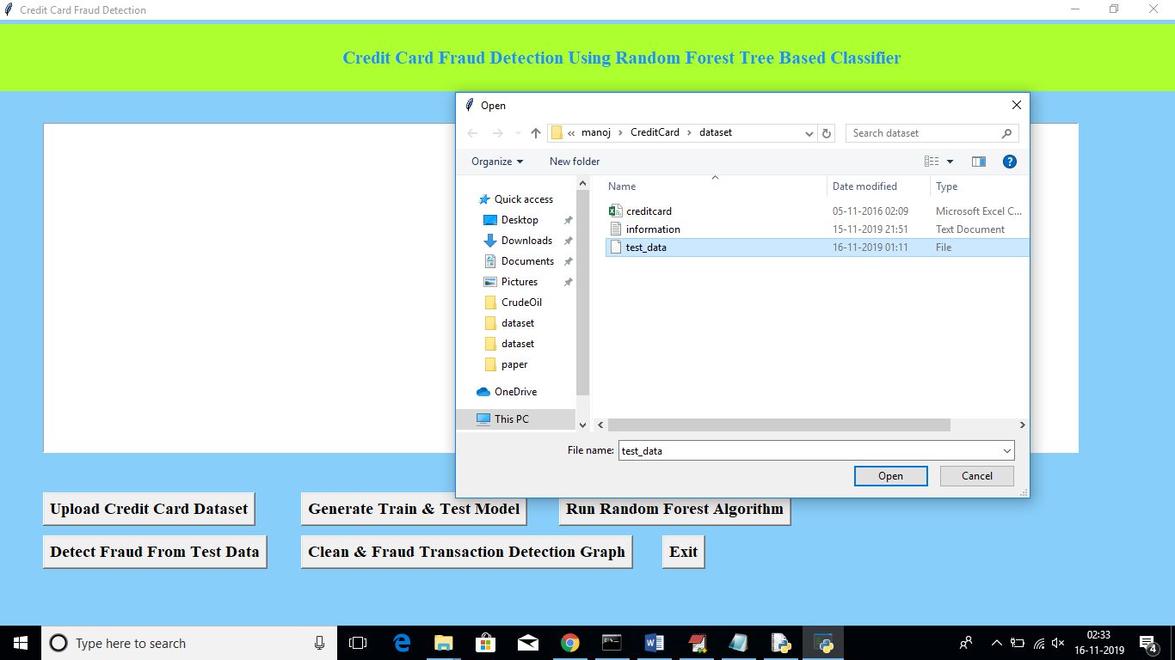

In above screen I am uploading test dataset and after uploading test data will get below prediction details

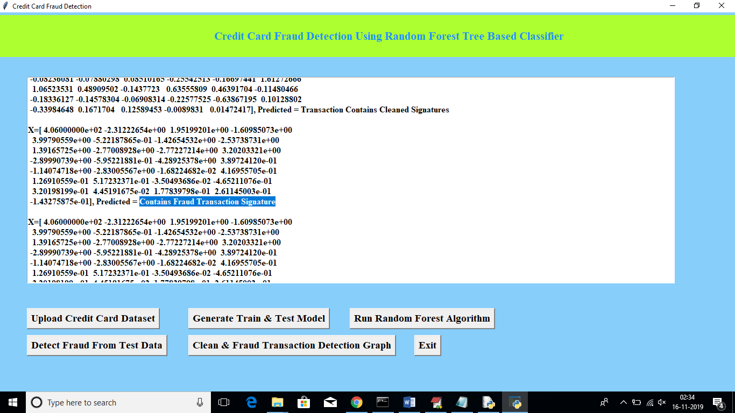

In above screen beside each test data application will display output as whether transaction contains cleaned or fraud signatures. Now click on ‘Clean & Fraud Transaction Detection Graph’ button to see total test transaction with clean and fraud signature in graphical format. See below screen

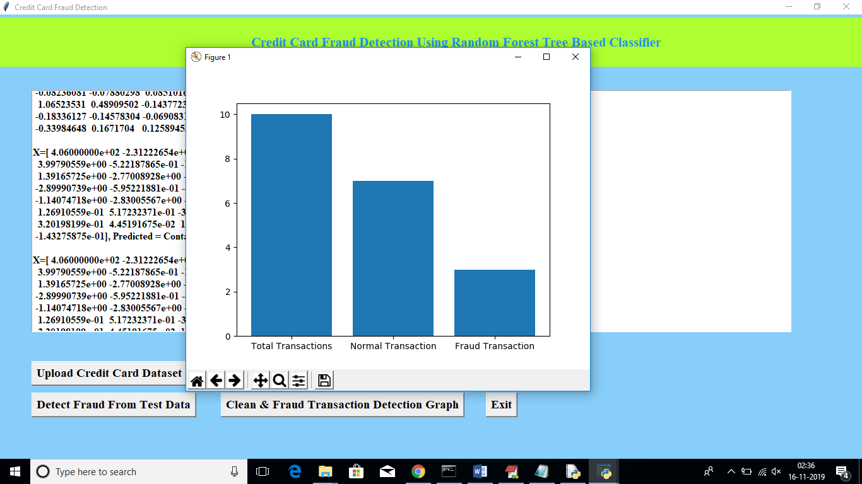

In above graph we can see total test data and number of normal and fraud transaction detected. In above graph x-axis represents type and y-axis represents count of clean and fraud transaction